**CPE 343 – Computer Organization & Architecture**



**Write here**

**Lab # 4**

**Title: Design the sequential circuit using VHDL programming techniques.**

|  |  |
| --- | --- |
| Name | Abdul Basit |
| Registration Number | FA17-BCE-062 |
| Class | FA17-BCE-B |
| Instructor’s Name | Moazzam Ali Sahi |

**INTRODUCTION:**

Combination circuits are the type of circuits we are working on till now but now onwards we will study sequential circuits. Sequential circuits are the type of circuit which are similar to other type they have memory which means their output is not only dependent input but also their previous output.

There are two types of sequential circuits

* Synchronous
* Asynchronous

**LAB TASKS: (In-Lab Tasks)**

D-Flip Flop (Asynchronous)

**Task 1:**

1. VHDL Code

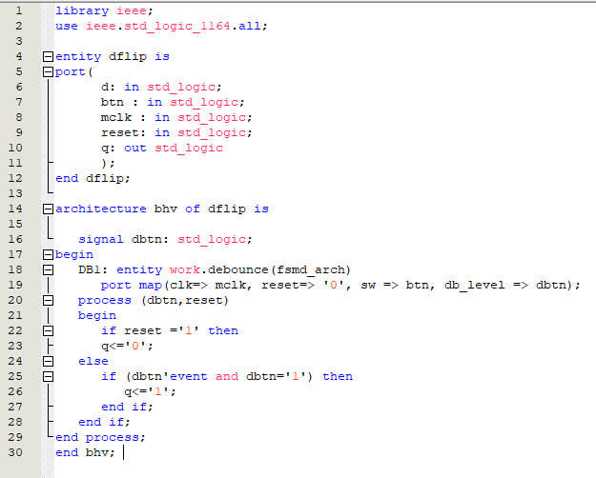

1. Results (VWF)

**Task 2:**

D-Flip Flop (synchronous)

1. VHDL Code

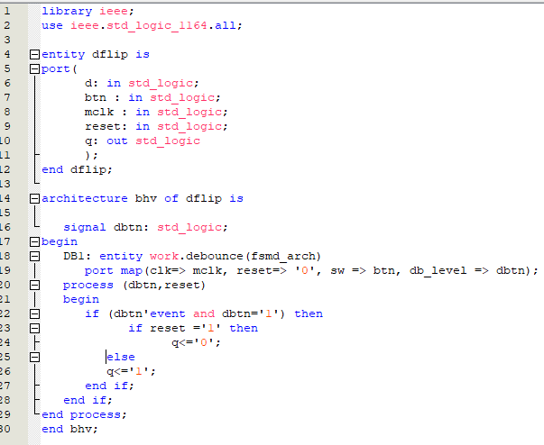

1. Results (VWF)

# CONCLUSION:

In this lab I learned how synchronous and Asynchronous circuits work. how to slow the clock cycle and control clock using button.